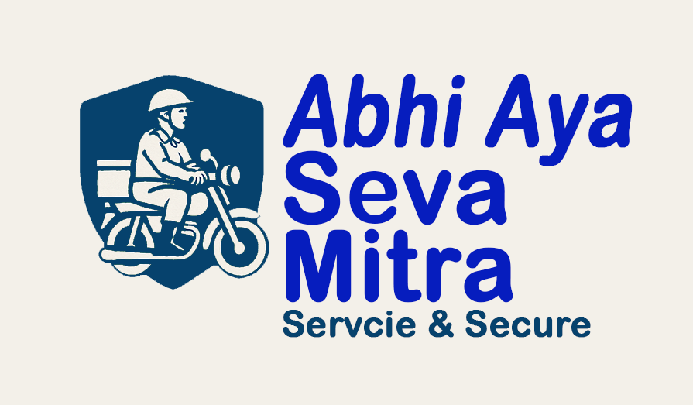

Abhi Aya Seva Mitra Scheme

"Your Companion for Every Need – Service with Care, Security Assured"

# 1. Introduction

The Abhi Aya Seva Mitra Scheme is a social service and livelihood program under the Ardh Sainik Mall Distribution & Retail Model.  
  
Abhi Aya Seva Mitra functions as the official delivery partner for:  
- All buyers of IndianMSME.org, who will automatically avail this delivery service.  
- Any market store or retail outlet interested in using this facility by registering as a buyer on IndianMSME.org.  
  
Thus, Seva Mitra services are available for:  
- Store Owners (retailers, wholesalers, canteens)  
- End Users (general public using the Abhi Aya mobile application).

# 2. Purpose & Vision

- To strengthen the Ardh Sainik Distribution & Retail Chain with a reliable last-mile delivery partner.  
- To create a network of Seva Mitras linked with buyers having ADC (Abhi Aya Delivery Centre) Codes.  
- To ensure every order from IndianMSME.org and local stores reaches the customer with speed, safety, and trust.  
- To empower youth and soldier families with employment, referral income, and respect.  
  
Vision Statement: 'Abhi Aya Seva Mitra – Delivery Partner of Ardh Sainik Distribution & IndianMSME.org.'

# 3. Services Offered by Seva Mitra

|  |  |  |
| --- | --- | --- |
| Category | Services Provided | Beneficiaries |
| Household Support | Grocery, milk, vegetables, medicines delivery | Families, Elderly, Differently-abled |
| Health Support | Patient transport, hospital assistance, medical equipment delivery | Patients, Caretakers |
| Children Support | Pick & drop to school/tuition, safe escort | Parents, Children |
| Canteen & Store Delivery | Orders from Ardh Sainik Canteens, IndianMSME.org buyers, Krishi Kendras, local stores | Retailers, Rural & Urban Families |
| Family & Social Help | Relatives pick & drop, emergency errands | Families, Women, Senior Citizens |

# 4. How the Delivery Model Works

1. Buyer Registration: All buyers of IndianMSME.org automatically access Abhi Aya Seva Mitra delivery service. Any market store can also register as a buyer on IndianMSME.org to avail delivery.  
  
2. ADC Code (Abhi Aya Delivery Centre): Each registered buyer is allotted a unique ADC Code. Seva Mitras get leads from all buyers linked with these ADC Codes.  
  
3. Order & Lead Allocation: Customers or stores place orders via IndianMSME.org or the Abhi Aya mobile app. Registered Seva Mitras in the respective PIN code area receive notifications. The Seva Mitra who accepts the order first gets the lead and completes the delivery.  
  
4. Transparency & Tracking: Every transaction is recorded in the app. Seva Mitras and buyers can track the delivery in real time.

# 5. Benefits for Applicants

- Regular Income: Earnings from deliveries across stores and IndianMSME.org.  
- Referral Income: Additional passive income through 5-generation referral model.  
- Business Opportunities: Leads from all registered buyers with ADC Codes.  
- Social Recognition: Trusted service provider in the community.  
- Training & Welfare: Free training, uniforms, insurance, and pension benefits.

# 6. Technology Platform

- Abhi Aya Mobile Application for buyers, stores, and Seva Mitras.  
- Features: Order booking & real-time tracking, lead notifications to Seva Mitras in the same PIN code, digital payments, invoices, and referral income dashboard.  
- Integrated with IndianMSME.org Buyer Network.  
- Helpline for elderly and offline users.

# 7. Fee & Payout Structure

|  |  |  |  |  |  |
| --- | --- | --- | --- | --- | --- |
| Service Type | Distance/Limit | Customer Fee | Seva Mitra Payout | Time Limit | Notes |
| Household Delivery | 0–1 km | ₹10 | ₹12 | 20 min | Affordable rate |
| Household Delivery | 1–2 km | ₹15 | ₹18 | 30 min | - |
| Household Delivery | 3–5 km | ₹30 | ₹35 | 60 min | Encourages longer trips |
| Health – Medicine | 0–3 km | ₹25 | ₹30 | 30 min | Urgent |
| Patient Transport | Within city | ₹100–₹150 | ₹120–₹180 | 1–2 hrs | Based on distance |
| Children Support | 0–2 km | ₹20 | ₹25 | School hrs | Verified only |
| Family Assistance | 5–10 km | ₹100 | ₹130 | 2 hrs | Station/Bus drop |
| Emergency Service | - | +₹20–₹50 | +₹15–₹40 | Immediate | Rain, night, urgent |

Incentives:  
- Peak Hour Bonus: +₹5/order  
- Daily Target Bonus: ₹50/day  
- Weekly Loyalty Bonus: ₹300/week

# 8. Referral Income Model (Up to 5 Generations)

|  |  |  |  |
| --- | --- | --- | --- |
| Generation | Team Size | Referral Income per Member | Total Income |
| Self | 1 | ₹0 | ₹0 |
| Gen-1 | 5 | ₹900 | ₹4,500 |
| Gen-2 | 15 | ₹500 | ₹7,500 |
| Gen-3 | 45 | ₹400 | ₹18,000 |
| Gen-4 | 115 | ₹300 | ₹34,500 |
| Gen-5 | 345 | ₹200 | ₹69,000 |
| Total | 526 | ₹2,300 | ₹1,33,500 |

With this, an applicant can earn up to ₹1.33 lakh in referral income, in addition to regular earnings.

# 9. Registration Process

1. Fill out the online application form and pay Rs.5100/- ref fee (including GST).   
2. Upload Aadhaar, Address Proof, Photograph, Police Verification.  
3. Attend training/orientation session.  
4. Receive uniform kit (ID card, 2 T-shirt, cap, bag).  
5. Start delivering & earning referral income.

# 10. Code of Conduct

- Wear official uniform & ID card on duty.  
- Be punctual, polite, professional.  
- Respect customer trust & confidentiality.  
- Misuse or misconduct = immediate termination.

# 11. Social Impact

- Citizens: Affordable & reliable doorstep services.  
- Stores: Last-mile delivery partner for all registered buyers of IndianMSME.org.  
- Youth: Employment and entrepreneurial income.  
- Soldier Families: Recognition & financial empowerment.  
- Elders & Vulnerable: Dependable support system.

# 12. Slogan

“Abhi Aya Seva Mitra – Delivery Partner of Ardh Sainik Distribution & IndianMSME.org”